《数字图像处理》实验报告

实验名称 ： 实验9彩色图像增强处理技术
实验日期 ： 2021.11.11

姓 名 ： 王译
学 号 ： 084519117
班 级 ： 19医信

成 绩 ：
信息技术学院
南京中医药大学

实验目的：
- 通过应用MATLAB语言编程实现对图像的处理，进一步熟悉MATLAB软件的编程及应用。
- 熟悉及掌握在MATLAB中如何实现彩色图像的平滑和锐化处理。
- 了解ice函数的用法，尝试自主实现类ice函数。
实验内容和要求
建立一个名为“xxxxx实验9”的解决方案（xxxxx为自己的学号）
- 学习ice函数的使用，通过阅读ice函数的脚本尝试自主开发曲线调节函数。
- 实现彩色图像的平滑处理
- 实现彩色图像的锐化处理
- 实现彩色图像的边缘检测及分割处理
- 将每一步的函数执行语句拷贝下来，写入实验报告，并且将得到第2~4步得到的图像效果拷贝下来。
运行结果（写清题号）
描述实验的基本步骤，用数据和图片给出各个步骤中取得的实验结果和源代码，并进行必要的讨论，必须包括原始图像及其计算/处理后的图像。
1． 学习ice函数的使用，通过阅读ice函数的脚本尝试自主开发曲线调节函数。
通过该种方式调用ice函数
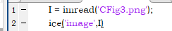
显示fig
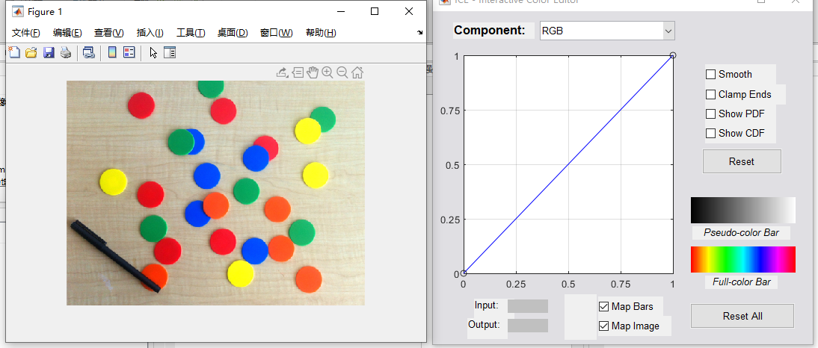
在ICE的GUI中提供了较为多的功能，首先是选择操作通道与色彩空间
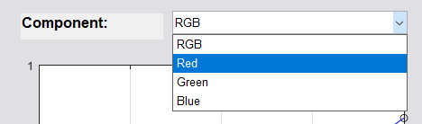
右边操作区如下
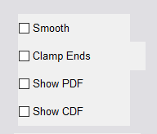
意思分别是：
Smooth:三次样条内插/分段线性内插
Clamp ends:三次样条内插中起始结束曲线斜坡为0
Show PDF:显示概率密度函数
Show CDF:显示累积分布函数
在set三个控制点后，点击Smooth，蓝线将因为插值而变得光滑。
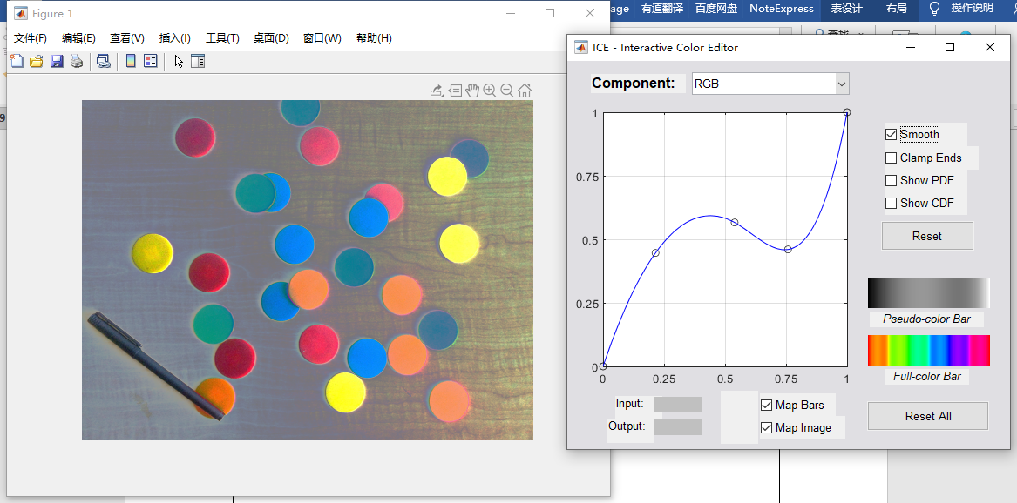
如果再点击Clamp ends，那么曲线的起始结束段的导数为0
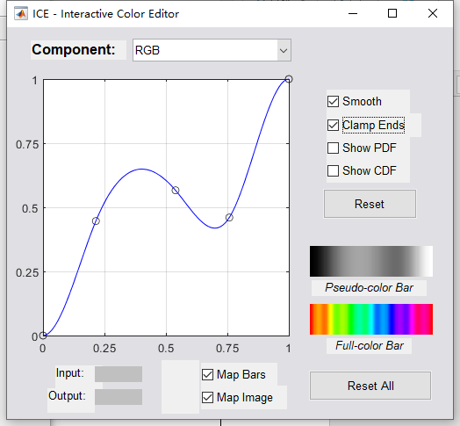
show PDF将图像的概率密度函数显示出来，其实有点类似直方图
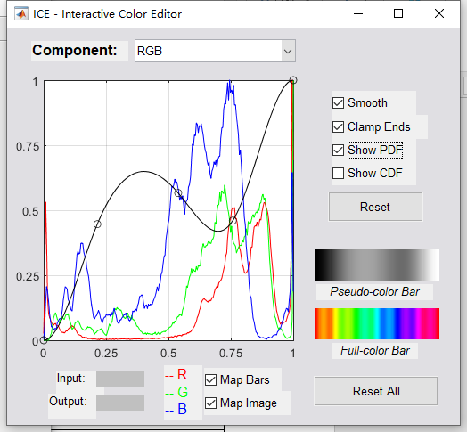
show CDF显示图像各种像素的累计分布，本质上和概率分布函数一样
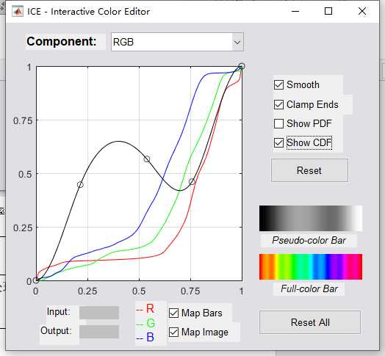
Map Image:启用图像映射
Map Bars:启用伪彩色和全彩色映射
通过阅读ice函数的脚本尝试自主开发曲线调节函数，在这个地方我复用了一些ICE中的代码，简化了GUI设计，如下：
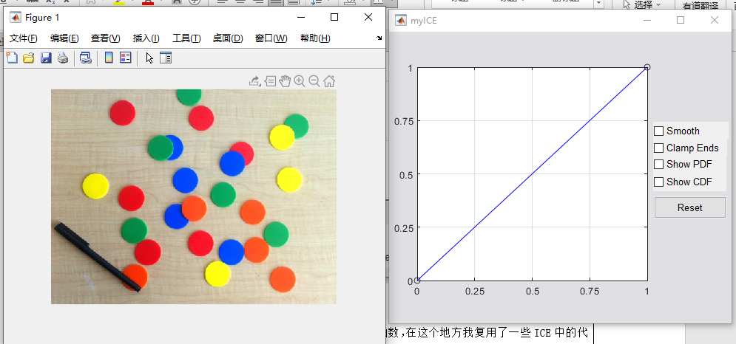
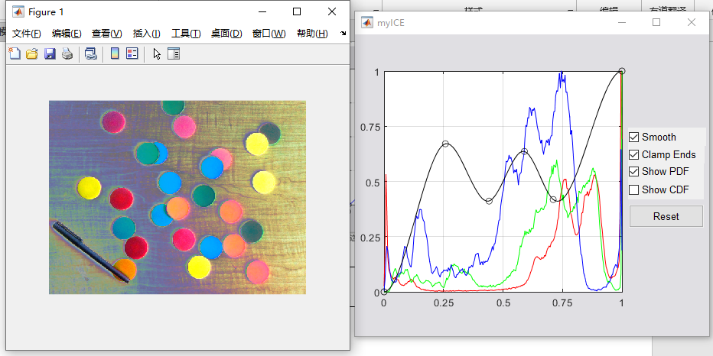
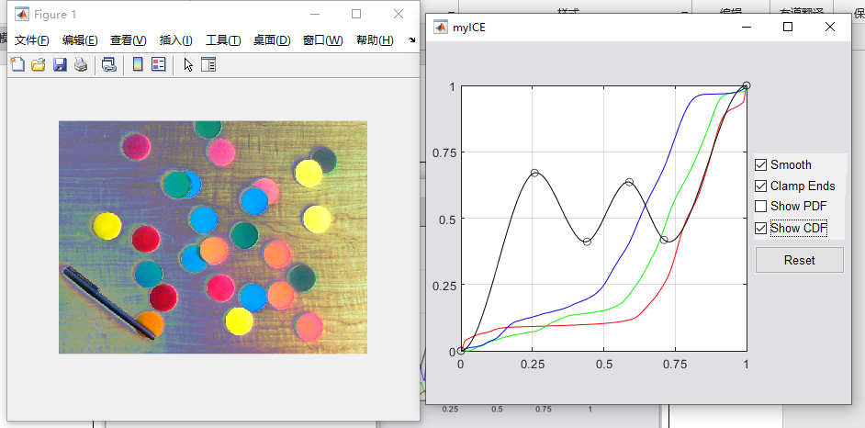
相关功能均可以正常使用。
2． 实现彩色图像的平滑处理
首先读入图像，加入噪声：
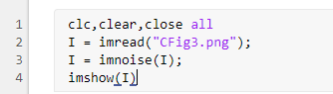
效果：
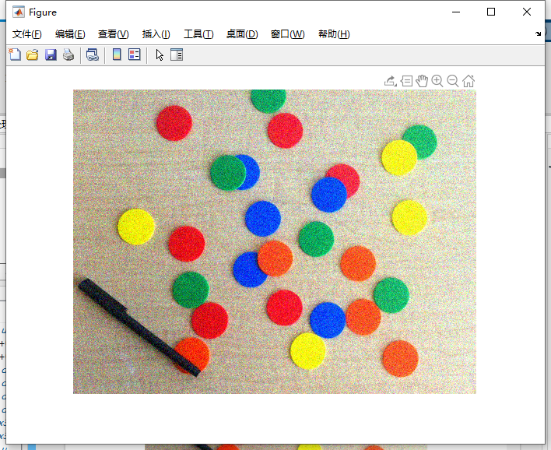
其实对于彩色图像的平滑处理，是对RGB三个通道图像分别进行平滑处理然后再cat，通过代码验证一下：
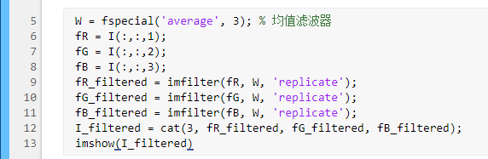
效果：
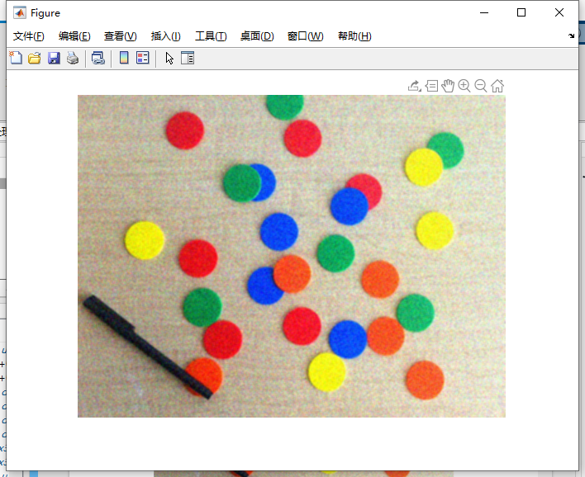
同时，为了比较各种平滑处理滤波器的优劣，定义了三种滤波器：均值，圆形平均，高斯，综合来看对于该图像，圆形平均效果最好。
代码：
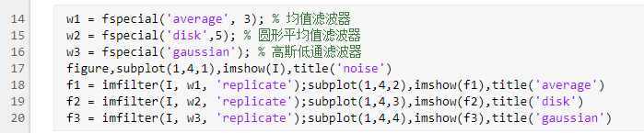
效果：
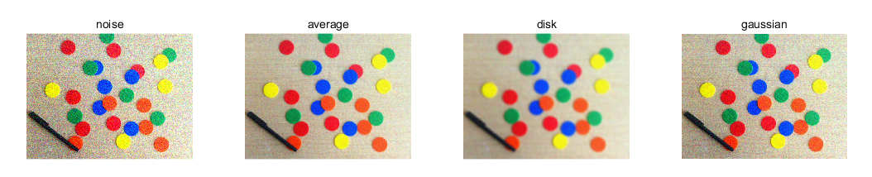
3． 实现彩色图像的锐化处理
同理，彩色图像的锐化处理也是先对三个通道进行锐化之后再cat，在这里为了凸显锐化的用处，我先对图像进行平滑处理，接着利用拉普拉斯算子对图像进行锐化，观察效果。
代码：
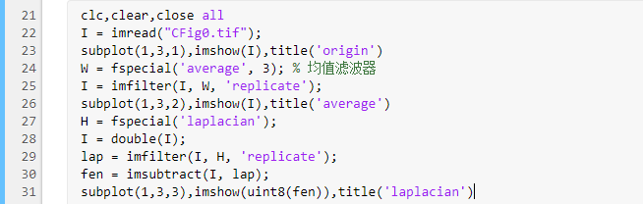
结果：
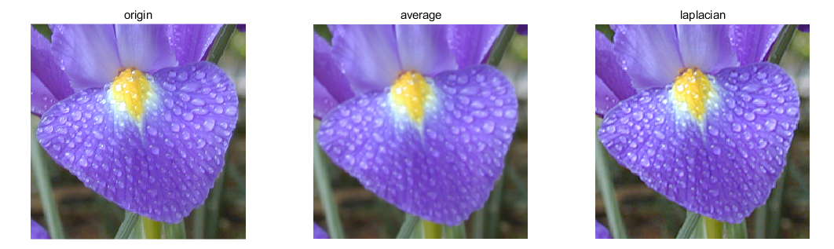
可以看到经过锐化处理过后的水滴边缘变得清晰。
4． 实现彩色图像的边缘检测及分割处理
教材上详细叙述了如何利用一阶导数二阶导数计算图像中的梯度信息进而检测出图像中的边缘信息，调用colorgrad实现该功能，我还比较了其与Canny边缘检测方法结果。
代码：
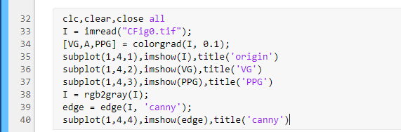
结果：
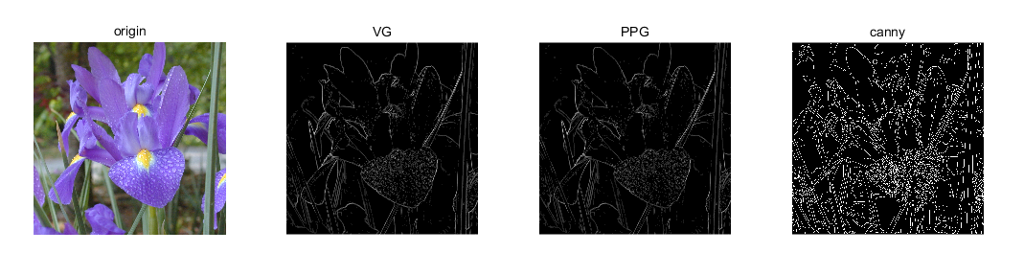
VG：是RGB向量梯度，PPG：是通过对各个彩色平面的二维梯度图像求和形成的梯度图像，可以看到VG和PPG将花朵的主要轮廓描述的比较好，而Canny将整幅图像的边缘信息描述的很全面。
在图像分割上，首先利用roipoly绘制感兴趣的区域：
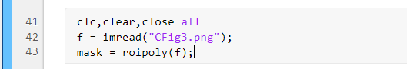
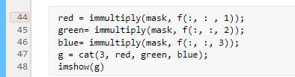
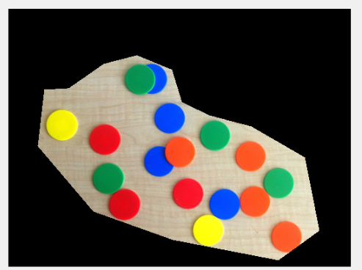
计算向量均值和协方差
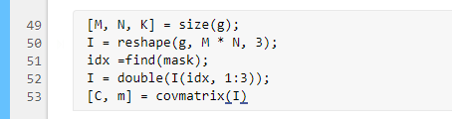
调用colorseg，利用euclidean方法
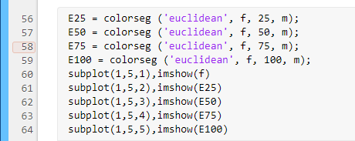
效果：
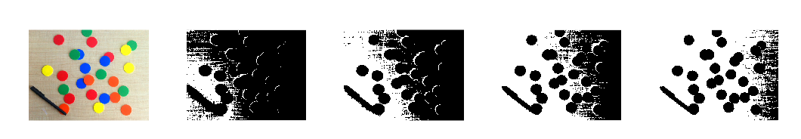
调用colorseg，利用mahalanobis方法
代码：
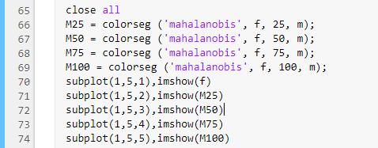
效果：
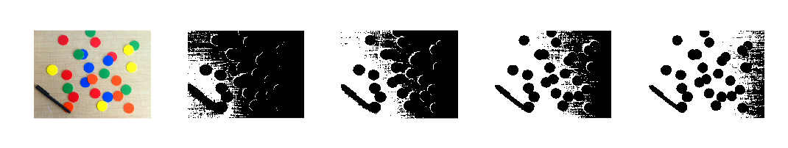
Euclidean 指Euclidean measure of similarity，欧几里得距离进行相似性度量
Mahalanobis 指Mahalanobis distance as a measure of similarity，马氏距离进行相似性度量
上述两种处理方法的结果差别不大，都能较好的分割出图像出的圆形。
在colorseg中的第三个参数是threshold，当阈值为100时，图像得到完全分割。m为向量均值。

上述实验调用用到的函数：
function [VG,A,PPG]=colorgrad(f,T)
%COLORGRAD Computes the vector gradient of an RGB image.
% [VG, VA, PPG] = COLORGRAD(F, T) computes the vector gradient, VG,
% and corresponding angle array, VA, (in radians) of RGB image
% F. It also computes PPG, the per-plane composite gradient
% obtained by summing the 2-D gradients of the individual color
% planes. Input T is a threshold in the range [0, 1]. If it is
% included in the argument list, the values of VG and PPG are
% thresholded by letting VG(x,y) = 0 for values <= T and VG(x,y) =
% VG(x,y) otherwise. Similar comments apply to PPG. If T is not
% included in the argument list then T is set to 0. Both output
% gradients are scaled to the range [0, 1].
% Copyright 2002-2004 R. C. Gonzalez, R. E. Woods, & S. L. Eddins
% Digital Image Processing Using MATLAB, Prentice-Hall, 2004
% $Revision: 1.6 $ $Date: 2003/11/21 14:27:21 $
if (ndims(f) ~= 3) || (size(f,3) ~=3)
error('Input image must be RGB.');
end
% Compute the x and y derivatives of the three component images
% using Sobel operators.
sh=fspecial('sobel');
sv=sh';
Rx=imfilter(double(f(:,:,1)),sh,'replicate');
Ry=imfilter(double(f(:,:,1)),sv,'replicate');
Gx=imfilter(double(f(:,:,2)),sh,'replicate');
Gy=imfilter(double(f(:,:,2)),sv,'replicate');
Bx=imfilter(double(f(:,:,3)),sh,'replicate');
By=imfilter(double(f(:,:,3)),sv,'replicate');
%Compute the parameters of the vector gradient.
gxx=Rx.^2+Gx.^2+Bx.^2;
gyy=Ry.^2+Gy.^2+By.^2;
gxy=Rx.*Ry+Gx.*Gy+Bx.*By;
A=0.5*(atan(2*gxy./(gxx-gyy+eps)));
G1=0.5*((gxx+gyy)+(gxx-gyy).*cos(2*A)+2*gxy.*sin(2*A));
% Now repeat for angle + pi/2. Then select the maximum at each point.
A=A+pi/2;
G2=0.5*((gxx+gyy)+(gxx-gyy).*cos(2*A)+2*gxy.*sin(2*A));
G1=G1.^0.5;
G2=G2.^0.5;
% Form VG by picking the maximum at each (x,y) and then scale
% to the range [0, 1].
VG=mat2gray(max(G1,G2));
% Compute the per-plane gradients.
RG=sqrt(Rx.^2+Ry.^2);
GG=sqrt(Gx.^2+Gy.^2);
BG=sqrt(Bx.^2+By.^2);
% Form the composite by adding the individual results and
% scale to [0, 1].
PPG=mat2gray(RG+GG+BG);

% Threshold the result.
if nargin==2
VG=(VG>T).*VG;
PPG=(PPG>T).*PPG;
end
end

function [C, m] = covmatrix(X)
%COVMATRIX Computes the covariance matrix of a vector population.
% [C, M] = COVMATRIX(X) computes the covariance matrix C and the
% mean vector M of a vector population organized as the rows of
% matrix X. C is of size N-by-N and M is of size N-by-1, where N is
% the dimension of the vectors (the number of columns of X).
[K, n] = size(X);
X = double(X);
if n==1%
C=0;
m=X;
else
%Compute an unbiased estimate of m
m=sum(X,1)/K;
%Subtract the mean from each row of X
X=X-m(ones(K,1), :);
%Computr an unbiased estimate of C . Note that the produc is
%X'*X because the vectors are rows of X
C=(X'*X)/(K-1);
m=m';%Convert to a column vector
end
end

function [X, R] = imstack2vectors(S, MASK)
%IMSTACK2VECTORS Extracts vectors from an image stack.
% [X, R] = imstack2vectors(S, MASK) extracts vectors from S, which
% is an M-by-N-by-n stack array of n registered images of size
% M-by-N each (see Fig. 11.24). The extracted vectors are arranged
% as the rows of array X. Input MASK is an M-by-N logical or
% numeric image with nonzero values (1s if it is a logical array)
% in the locations where elements of S are to be used in forming X
% and 0s in locations to be ignored. The number of row vectors in X
% is equal to the number of nonzero elements of MASK. If MASK is
% omitted, all M*N locations are used in forming X. A simple way
% to obtain MASK interactively is to use function roipoly. Finally,
% R is an array whose rows are the 2-D coordinates containing the
% region locations in MASK from which the vectors in S were
% extracted to form X.

% Copyright 2002-2004 R. C. Gonzalez, R. E. Woods, & S. L. Eddins
% Digital Image Processing Using MATLAB, Prentice-Hall, 2004
% $Revision: 1.6 $ $Date: 2003/11/21 14:37:21 $

% Preliminaries.
[M, N, n] = size(S);
if nargin == 1
MASK = true(M, N);
else
MASK = MASK ~= 0;
end

% Find the set of locations where the vectors will be kept before
% MASK is changed later in the program.
[I, J] = find(MASK);
R = [I, J];

% Now find X.

% First reshape S into X by turning each set of n values along the third
% dimension of S so that it becomes a row of X. The order is from top to
% bottom along the first column, the second column, and so on.
Q = M*N;
X = reshape(S, Q, n);

% Now reshape MASK so that it corresponds to the right locations
% vertically along the elements of X.
MASK = reshape(MASK, Q, 1);

% Keep the rows of X at locations where MASK is not 0.
X = X(MASK, :);
end

function I = colorseg(varargin)
%COLORSEG Performs segmentation of a color image.
% S = COLORSEG('EUCLIDEAN', F, T, M) performs segmentation of color
% image F using a Euclidean measure of similarity. M is a 1-by-3
% vector representing the average color used for segmentation (this
% is the center of the sphere in Fig. 6.26 of DIPUM). T is the
% threshold against which the distances are compared.
%
% S = COLORSEG('MAHALANOBIS', F, T, M, C) performs segmentation of
% color image F using the Mahalanobis distance as a measure of
% similarity. C is the 3-by-3 covariance matrix of the sample color
% vectors of the class of interest. See function covmatrix for the
% computation of C and M.
%
% S is the segmented image (a binary matrix) in which 0s denote the
% background.

% Copyright 2002-2004 R. C. Gonzalez, R. E. Woods, & S. L. Eddins
% Digital Image Processing Using MATLAB, Prentice-Hall, 2004
% $Revision: 1.5 $ $Date: 2003/11/21 14:28:34 $

% Preliminaries.
% Recall that varargin is a cell array.
f = varargin{2};
if (ndims(f) ~= 3) | (size(f, 3) ~= 3)
error('Input image must be RGB.');
end
M = size(f, 1); N = size(f, 2);
% Convert f to vector format using function imstack2vectors.
[f, L] = imstack2vectors(f);
f = double(f);
% Initialize I as a column vector. It will be reshaped later
% into an image.
I = zeros(M*N, 1);
T = varargin{3};
m = varargin{4};
m = m(:)'; % Make sure that m is a row vector.

if length(varargin) == 4
method = 'euclidean';
elseif length(varargin) == 5
method = 'mahalanobis';
else
error('Wrong number of inputs.');
end

switch method
case 'euclidean'
% Compute the Euclidean distance between all rows of X and m. See
% Section 12.2 of DIPUM for an explanation of the following
% expression. D(i) is the Euclidean distance between vector X(i,:)
% and vector m.
p = length(f);
D = sqrt(sum(abs(f - repmat(m, p, 1)).^2, 2));
case 'mahalanobis'
C = varargin{5};
D = mahalanobis(f, C, m);
otherwise
error('Unknown segmentation method.')
end

% D is a vector of size MN-by-1 containing the distance computations
% from all the color pixels to vector m. Find the distances <= T.
J = find(D <= T);

% Set the values of I(J) to 1. These are the segmented
% color pixels.
I(J) = 1;

% Reshape I into an M-by-N image.
I = reshape(I, M, N);
end

实验的体会与思考题
- 彩色图像与灰度图像在实现平滑和锐化处理的异同？
彩色图像与灰度图像的本质区别就是通道数不一样，对于灰度图像的平滑锐化处理，只对单通道处理，对于彩色图像其实就是在三个通道上分别处理(相同点)，将处理完的结果再拼接在一起(不同点)，就形成了对彩色图像整体的平滑或锐化。

